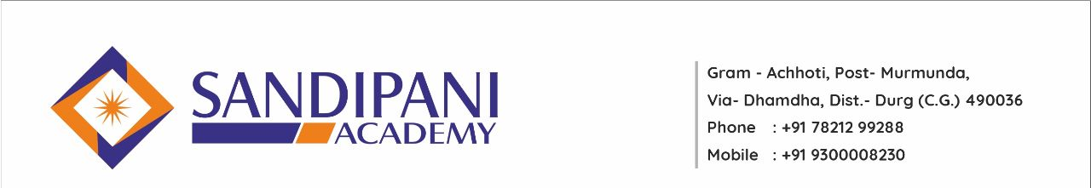
Faculty Development Program

Event Name – Innovation in E-Learning & Learning Management System
Date & Venue – 8th & 9th July 2021, Sandipani Academy Achhoti, Dist. – Durg (C.G.)

Under the aegis of Education Department of Sandipani Academy Achhoti, has organized 2 days FDP on topic – “Innovation in E-Learning & Learning Management System”. The chief Guest of this programme were Prof. Dr. Rajeev Choudhary (Dean, Students’ welfare DMS Head, school of Studies in Law Pt. Ravishankar Shukla University Raipur, Chhattisgarh) & Dr. Prashant Shrivastav (Dean, students’ Welfare DMS Hemchand Yadav Vishwavidyalay Durg, Chhattisgarh) keynote speaker Mr. Manish Singh (Solution Architect Digital API Craft Bengaluru, Tamilnadu) & Dr. Riya Tiwari (Principal, Gracious College of Education Belbhata, Abhanpur). The co-ordinators of this event were Ms. Meena Pandey, Ms. Saroj Shukla, Ms. Mamta Dhruw, Ms. Tripti Madhariya Asst. Prof. of Sandipani Academy.
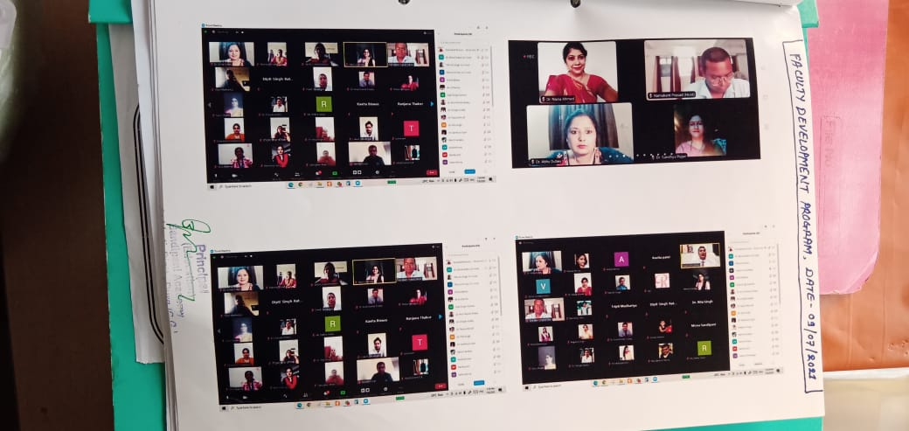
Also we extend our special thanks to our Hon. Director Mr. Mahendra Choubey, administrative officer Mr. Vineet Choubey, Head of Department Dr. Sandhya Pujari, Chief Advisor Dr. Abha Dubey and all the staff members who equally contributed for making this program successful.

Faculty Development Program

Event Name – “Imbibing Integral Education in New Education Policy”
Date & Venue – 16th Aug 2021, Sandipani Academy Achhoti, Dist. – Durg (C.G.)

Under the aegis of Education Department of Sandipani Academy Achhoti, has organized one day FDP on topic – “Imbibing Integral Education in New Education Policy”. The chief guest of this seminar was Dr. Samarendra Mohan Ghosh (Managinas Director of Shri Aurbindo Yoga and Knowlage Foundation), and Keynote Speaker Ms Indrani Ghosh (Trustee of Shri Aurbindo Yoga and Knowlage Foundation) & Dr. Kiran Bala Patel. The co-ordinators of this event were Ms. Vidya Chandrakar, Mr. Vivek Kumar Gautam, Mr. Lokesh Dewangan Asst. Prof. of Sandipani Academy.
Also we extend our special thanks to our Hon. Director Mr. Mahendra Choubey, administrative officer Mr. Vineet Choubey, Head of Department Dr. Sandhya Pujari, Chief Advisor Dr. Abha Dubey and all the staff members who equally contributed for making this program successful.
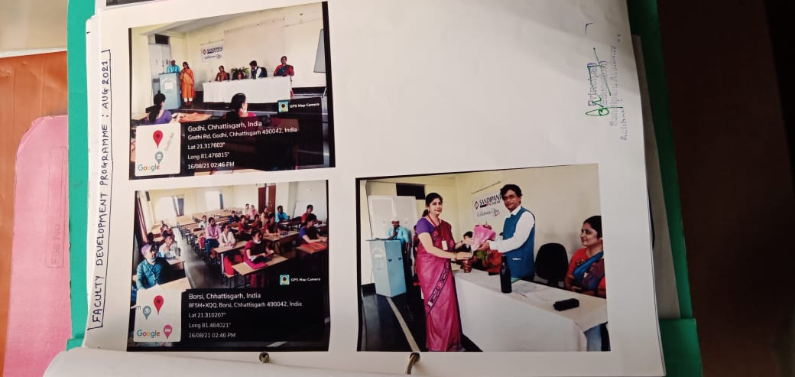

FACULTY DEVELOPMENT PROGRAMME
Activity name- “Managing Inner Harmony for better Teaching Learning”
Date and Venue-26/02/2022, Sandipani Academy Achhoti (Durg)

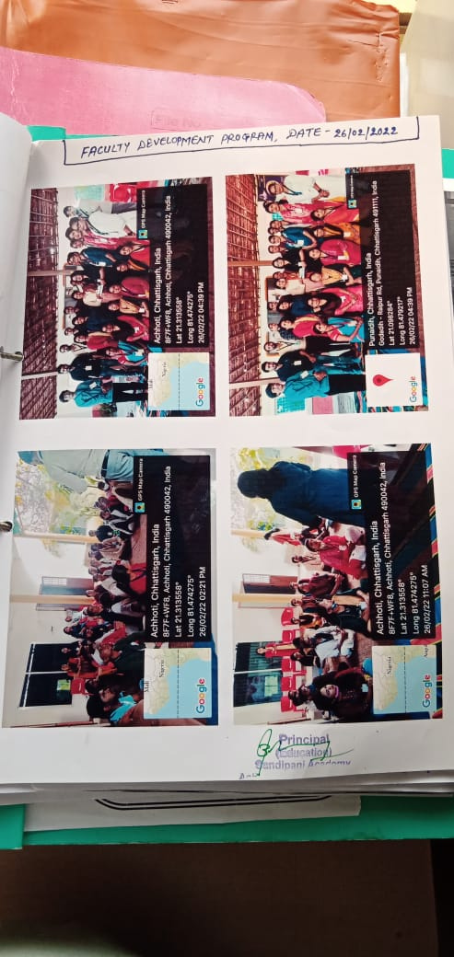
Under the aegis of Education department of Sandipani Academy Achhoti Durg organized a one day faculty development program on the subject "Managing Inner Harmony for better Teaching Learning" at Shri Aurbindo Yoga & Knowledge Foundation. Keynote Speaker were Dr. Samarendra Mohan Ghosh (Managinas Director of Shri Aurbindo Yoga and Knowlage Foundation), Ms Indrani Ghosh (Trustee of Shri Aurbindo Yoga and Knowlage Foundation) & Dr. Kiran Bala Patel. The co-ordinators of this event is Ms. Mamta Dhruw Asst. Prof. of Sandipani Academy Durg.

Also we extend our special thanks to our Hon. Director Mr. Mahendra Choubey, administrative officer Mr. Vineet Choubey, Head of Department Dr. Sandhya Pujari, Chief Advisor Dr. Abha Dubey and all the staff members who equally contributed for making this program successful

Faculty Development Program

Event Name – “Professional Ethics”
Date & Venue – 9th Oct 2021, Sandipani Academy Achhoti, Dist. – Durg (C.G.)

Under the aegis of Education Department of Sandipani Academy Achhoti, has organized one day FDP on topic – “Professional Ethics”. The Keynote Speaker of this program was Dr. Abha Dudey mam (Advisor of Sandipani Academy Achhoti Durg). The co-ordinator of this event was Ms. Preeti Dewangan Asst. Prof. of Sandipani Academy.
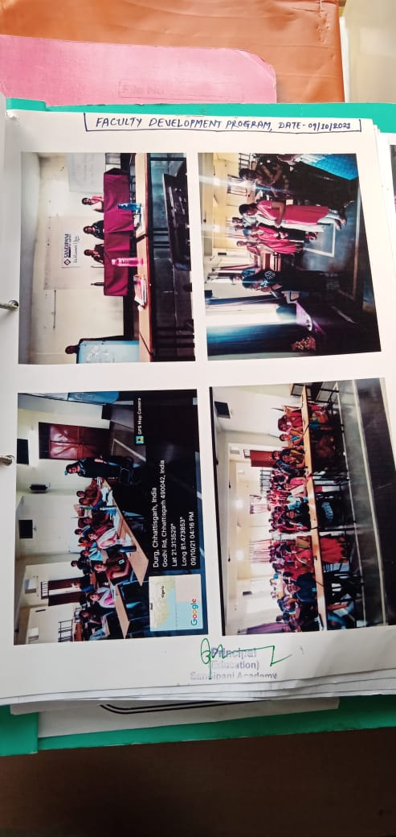
Also we extend our special thanks to our Hon. Director Mr. Mahendra Choubey, administrative officer Mr. Vineet Choubey, Principal Dr. Nazia Ahmed, Head of Department Dr. Sandhya Pujari, Chief Advisor Dr. Abha Dubey and all the staff members who equally contributed for making this program successful.

Faculty Development Program

Event Name – “Research Methodology and IPR”
Date & Venue – 29th Dec 2021, Sandipani Academy Achhoti, Dist. – Durg (C.G.)

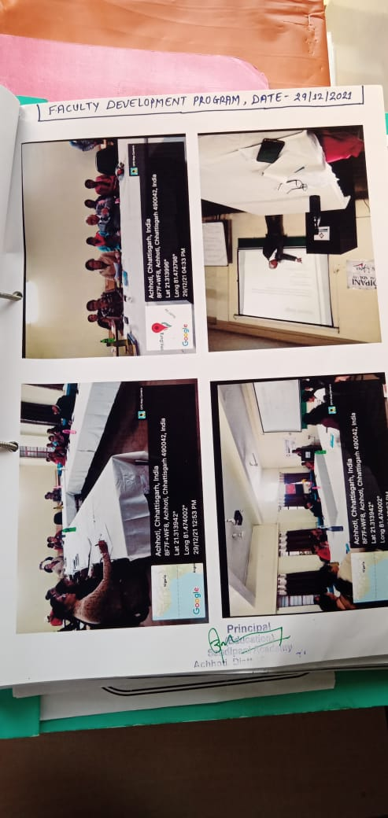
Under the aegis of Education Department of Sandipani Academy Achhoti, has organized one day FDP on topic – “Research Methodology and IPR”. The Keynote Speaker of this program was Dr.J.C. Ajawani (International Counselor & Motivational Speaker). The co-ordinators of this event were Ms. Meena Pandey & Ms. Preeti Dewangan Asst. Prof. of Sandipani Academy.
Also we extend our special thanks to our Hon. Director Mr. Mahendra Choubey, administrative officer Mr. Vineet Choubey, Principal Dr. Nazia Ahmed, Head of Department Dr. Sandhya Pujari, Chief Advisor Dr. Abha Dubey and all the staff members who equally contributed for making this program successful.

Faculty Development Program

Event Name – “Behaviour & Discipline”
Date & Venue – 9th Mar 2022, Sandipani Academy Achhoti, Dist. – Durg (C.G.)

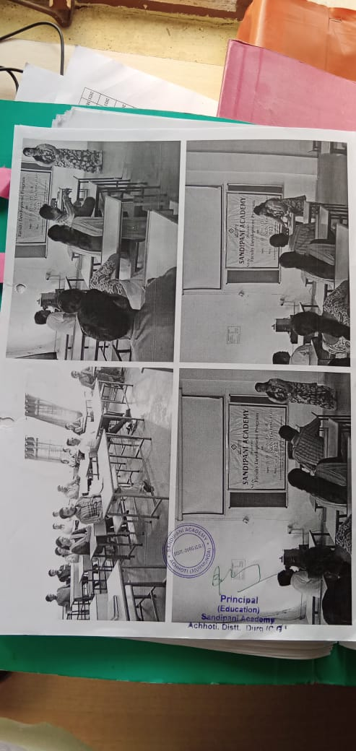
Under the aegis of Education Department of Sandipani Academy Achhoti, has organized one day FDP for Non-Teaching Staff on topic –“Behaviour & Discipline”. The Speaker & Co-ordinator of this program was Ms. Neha Kumbhar Asst. Prof. of Sandipani Academy.

Also we extend our special thanks to our Hon. Director Mr. Mahendra Choubey, administrative officer Mr. Vineet Choubey, Principal Dr. Nazia Ahmed, Head of Department Dr. Sandhya Pujari, Chief Advisor Dr. Abha Dubey and all the staff members who equally contributed for making this program successful.

